Algorithm
Design a BankAccount Class Ensuring Sufficient Balance for Withdrawal

Design a BankAccount Class

Use Case
Design a Bankaccount class that represents a real-world bank account and allows safe financial transactions such as deposit and withdrawal.

Objective
To create a bank account system using Object-Oriented Programming concepts and ensure that withdrawal is not allowed when the balance is insufficient.

Class Description
The BankAccount class acts as a blueprint for creating bank account objects. It stores account details and provides methods to perform banking operations.

Properties (Data Members)
- account_number
Stores the unique account number of the customer.
- account_holder_name
Stores the name of the account holder.
- balance
Stores the current available balance in the account.

Behaviors (Member Functions)

1. deposit(amount)
- Adds the specified amount to the account balance.
- Accepts only positive values.
- Prevents invalid deposit transactions.

2. withdraw(amount)
- Removes money from the account.
- Check whether the withdrawal amount is positive.
- Verifies if the account has sufficient balance before withdrawing.
- If the balance is insufficient, the withdrawal is rejected.
- This ensures safe and secure transactions.

3. display_balance()
- Displays account number, account holder name, and current balance.
- Helps the user track account details easily.

Working Process
- A Bank account object is created using account details.
- The user interacts with the system through a menu-driven interface.
- Based on the user’s choice, deposit or withdrawal operations are performed.
- Before withdrawing, the system checks for sufficient balance.
- If conditions are satisfied, the transaction is completed successfully.

Conclusion
The Bank account class provides a secure and structured way to manage bank accounts.
By restricting withdrawals when the balance is insufficient, it ensures financial safety and demonstrates effective use of Object-Oriented Programming concepts.

DFD
Level 1 Data Flow Diagram: BankAccount Class
Entity/Component | Description
External Entity | Account Holder / User (Initiates actions)
Processes | 1.0 Deposit, 2.0 Withdraw, 3.0 Display Balance
Data Store | Accounts Database (Stores account_number, account_holder_name, balance)

Data Flows by Process
- 1.0 Deposit(amount)
  - Input: User provides deposit_amount.
  - Logic: Process 1.0 receives the amount and the current balance from the Data Store.
  - Update: New balance (balance + amount) is sent back to the Data Store.
  - Output: "Deposit Successful" message to the User.
- 2.0 Withdraw(amount)
  - Input: User provides withdrawal_amount.
  - Validation: Process 2.0 retrieves the current balance from the Data Store.
  - Decision Logic:
    - If amount <= balance: New balance (balance - amount) is saved to the Data Store.
    - If amount > balance: An "Insufficient Funds" error message is sent to the User; no update is made to the Data Store.
  - Output: Success or Failure confirmation to the User.
- 3.0 Display Balance
  - Request: User requests "Display Balance".
  - Retrieval: Process 3.0 fetches account_number, name, and balance from the Data Store.
  - Output: Account summary (all properties) is displayed to the User.
Key Components for Design
- Processes (Circles/Rounded Rectangles): Represent the deposit(), withdraw(), and display_balance() behaviors.
- Data Store (Open-ended Rectangles): Represents the BankAccount object's memory or a database where properties are held.
- Data Flows (Arrows): Show the specific pieces of information (like amount or status) moving between entities and processes.
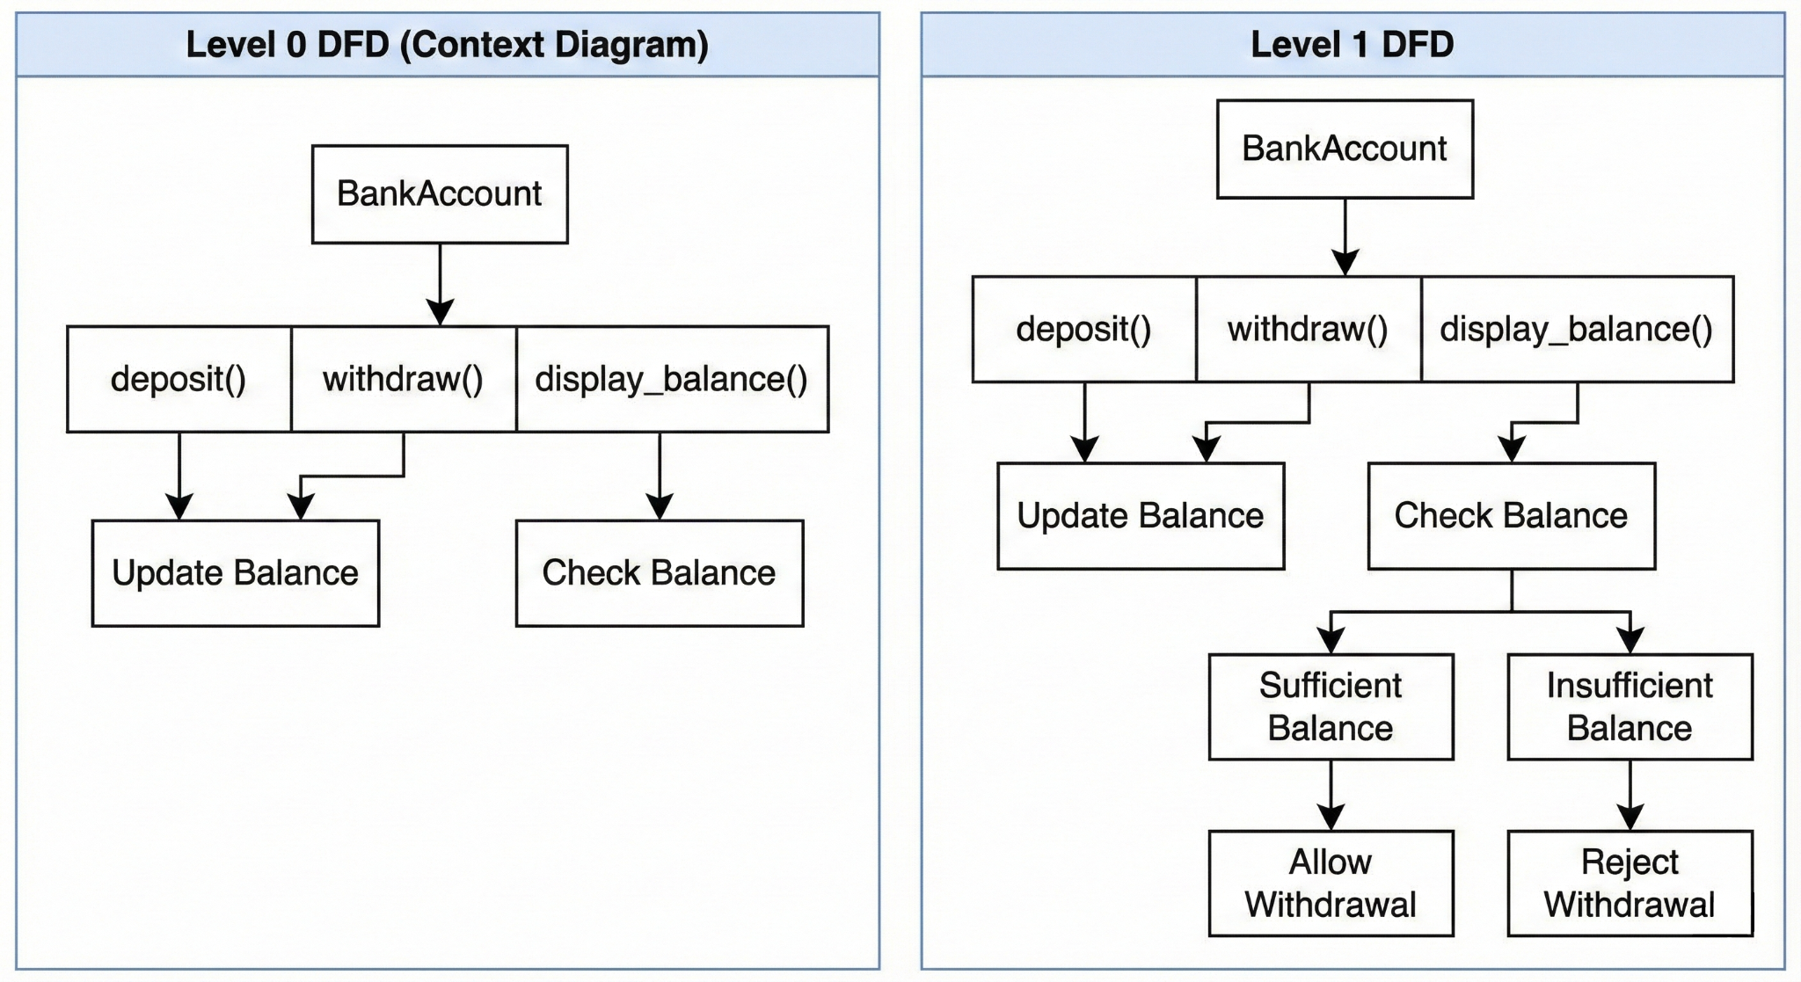

Flowchart
FLOWCHART for Bank Account Program

